ASCE Conference Proceedings Paper
Formatting Instructions

Isabella M. Author, Ph.D.,¹ Brandon Q. Writer, AIA,² and
Charles O. Author, P.E., M.ASCE³

¹Hard Knocks Laboratory, Department of Civil and Environmental Engineering, Research State University, P.O. Box 98765, City, ST 99999-1111; e-mail: imauthor@rsu.edu
²Hard Knocks Laboratory, Department of Civil and Environmental Engineering, Research State University, P.O. Box 98765, City, ST 99999-1111; Writer & Bickering, LLC, 144 Main St., Megaville, ST 22222; e-mail: bqwriter@rsu.edu
³Everlasting Company, Mail Stop LC 444, 2233 West 32nd Avenue, Township, ST 88888; e-mail: co.author@everco.com

ABSTRACT (REQUIRED)

The abstract should consist of one paragraph of about 150 words. The abstract should present a concise statement of the scope, principal findings, and conclusions of your project. Abstracts cannot include lists, tables, figures, display equations, footnotes, or references.

INTRODUCTION (REQUIRED)

You should be giving high-level descriptions of your project here. You can also discuss your understanding of the project background as well as the dataset you are using, e.g., why this topic, why this scope, why this source. Based on these discussion, listing and justifying your hypotheses here is great.

DATA (REQUIRED)

This section is dedicated to describing your data sources, challenges they bring, your management plan (e.g., schemas, relationships, keys, etc.), and exploration of the features that can help your audience get a comprehensive picture of your data as quickly as possible. If you are pre-processing your data, you can also describe it here (e.g., aggregate loop data from 20s to 5min).

ANALYSIS AND RESULTS (REQUIRED)

Now your team have identified some big questions to answer and have collected some datasets that you believe is adequate. It’s about time to tell your story here in this section. As briefly discussed in Feb 23 lecture, you can discuss what to analyze (e.g., a particular crash type and use crash frequency normalized by length of road segment), how to analyze (e.g., simple regressions), and what to present (e.g., what plots, tables, numbers, and interpretations). You can also include important code pieces here to tell people how you achieved a particular function. However, including code in this section shall not interfere with reading.
My advice is to use static plots in the report. I understand that you will be developing the data app in Streamlit and that’s mostly interactive and drawing some static plots seems additional task. But we will introduce plotting modules and functions in Python and you will soon find out efforts are shared between creating static plots via Matplotlib and interactive plots in Streamlit. Again it’s totally up to you what and how to present, as long as they are readable for your audiences.

CONCLUSION (REQUIRED)

This is where you are summarizing your project. A link to the Streamlit data app should be included here.

ACKOWLEDGEMENT (REQUIRED)

Place to identify roles/responsibilities of your team members.

REFERENCES (OPTIONAL)

If there is any.

OTHER FORMATTING REQUIREMENTS (TO BE DELETED IN THE PRODUCT)

Length. Length is for this project report is 6 pages, including everything. Your code is submitted separately in .py files.

Point size and font. Use 12 point type for text, captions, and author contact information. For type within figures or tables, the 12 point size is preferred. ASCE Publications recommends selecting a serif text font such as Times Roman. Italics, bold, and bold italics may be used; using only one “family” of typefaces yields the cleanest results.

Headers and footers. Do not put any information in the header. The only acceptable content in the footer is a single page number.

Layout. All text must be single-spaced. Page design should be consistent throughout the paper. Margins should be 1 inch (25.4 mm) on all sides, and all elements (text, figures, tables, captions) must fit within those margins.

Figures and tables. All graphics (photos, line art, and tables) must be included electronically (embedded) within the document and fit within the margin settings.
Illustrations should be numbered consecutively as they are presented (Figure 1, Figure 2, etc., and Table 1, Table 2, etc.). Each figure should be mentioned in the text or “called out” before it appears.
Figures may be placed in the text or in a “gallery” at the end of the paper. More than one figure may appear on a page. Do not wrap text around the figure, even to save space. Landscape orientation is acceptable.

Table 1. Sample table demo.
User | Date | Time | Route & Station | Mode | Price | Discount
132945 | 2016-3-27 | 11:34:08 | Line 2 ZhongShan Park | Metro | 0.0 | not applied
132945 | 2016-3-27 | 11:57:13 | Line 11 LongHua | Metro | 4.0 | applied
132945 | 2016-3-27 | 14:49:01 | Line 11 LongHua | Metro | 0.0 | not applied
132945 | 2016-3-27 | 15:31:15 | Line 2 LuJiaZui | Metro | 4.0 | applied
132945 | 2016-3-27 | 16:30:53 | None | Ferry | 2.0 | none
132945 | 2016-3-27 | 17:10:47 | None | Ferry | 1.0 | none
132945 | 2016-3-27 | 17:46:43 | Route 71 | Bus | 2.0 | not applied

Captions and legends. A descriptive caption, including figure number, should be placed directly below the illustration (see Figure 1). A descriptive legend, including table number, should be placed immediately above the table.

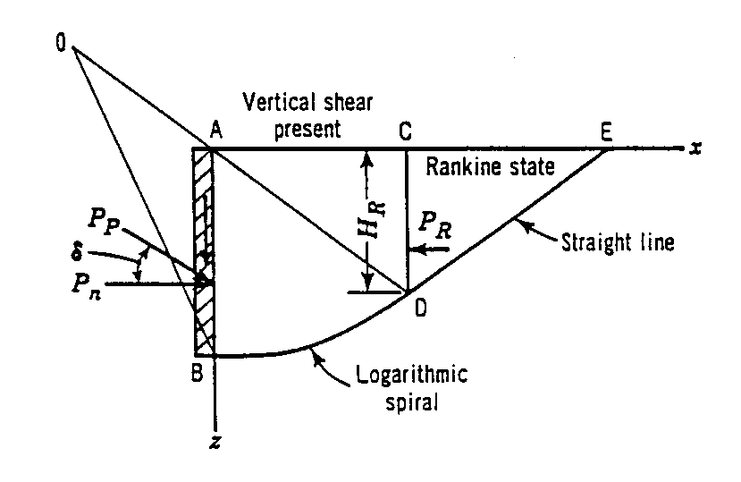
Figure 1. Sample line art illustration.

Style. The paper must be written in the best possible technical and grammatical English. Titles should be concise and should describe the content of the paper. If you have a long title, please consider a Title: Subtitle format. More information on writing style is available online.

Mathematics. All mathematics must be embedded in the text. Equations need to be numbered only if they are referred to more than once. More information on mathematics style is available online.

Author contact information. A sample of author contact information is shown on the first page of these instructions. The following information may be provided for all authors of the paper: author’s full name; academic degrees or honorifics; professional licenses; ASCE membership grade; current employment affiliation; mailing address; and e-mail address. Note that each author has one and only one note with contact information. Multiple authors with the same employment affiliation or mailing address must have separate notes.

References. All factual material that is not original with the author must be accompanied by a reference to its source. ASCE prefers the author-date system of referencing. The author-date system has two parts, the text citation and the reference list.

- The text citation appears where the material to be cited is presented and it refers readers to a source in the reference list by the author's last name and year of publication. Often, the author and date appear in parentheses; a comma is not placed between them.
- The reference list appears at the end of each proceedings paper. It should be single-spaced and list each reference alphabetically by the last name of the first author. When two or more references by the same author are listed, year of publication is taken into account, and the earliest work is listed first.

ASCE strongly discourages the use of superscripts to refer to references because the numbers often become unreadable when the pages are reproduced. Some sample references are listed at the end of this paper; see author-date references for more detailed information.

REFERENCES

ASCE (American Society of Civil Engineers). (2014) Minimim Design Loads for Buildings and Other Structures, Standard ASCE/SEI 7-10. Third printing. ASCE, Reston, VA.
Burka, L. P. (1993). “A hypertext history of multi-user dimensions.” MUD history, <http://www.ccs.neu.edu> (Dec. 5, 2013).
Committee on Curtain Wall Systems. (2014). Curtain Wall Systems: A Primer, ASCE Manuals and Reports on Engineering Practice No. 126. Memari, Ali M., ed. ASCE, Reston, VA.
Dhillon, Gurpreet S., Surinder Kaur, Ajila C. M., Brar, Satinder K., and Surampalli, Rao Y. (2013). “Greenhouse Gas Contribution on Climate Change.” Chapter 3 in Climate Change Modeling, Mitigation, and Adaptation, Rao Y. Surampalli, Tian C. Zhang, C. S. P. Ojha, B. Gurjar, R. D. Tyagi, and S. M. Kao, eds. ASCE, Reston, VA, 26-61.

